www.emberea.com

ACTION OVERVIEW:
Reaction-focused Interventions

SUMMARY
Targeting implementation actions to actual change reactions improves productive change response and decreases time to full adoption.

REACTIONS TO CHANGE
Our research shows the following four reactions to change:

- Fight/Flight
  - Combination of high perceived risk and high perceived complexity
- Test
  - Combination of high perceived risk and low perceived complexity
- Study
  - Combination of low perceived risk and high perceived complexity
- Implement:
  - Combination of low perceived risk and low perceived complexity in the presence of high perceived personal benefit

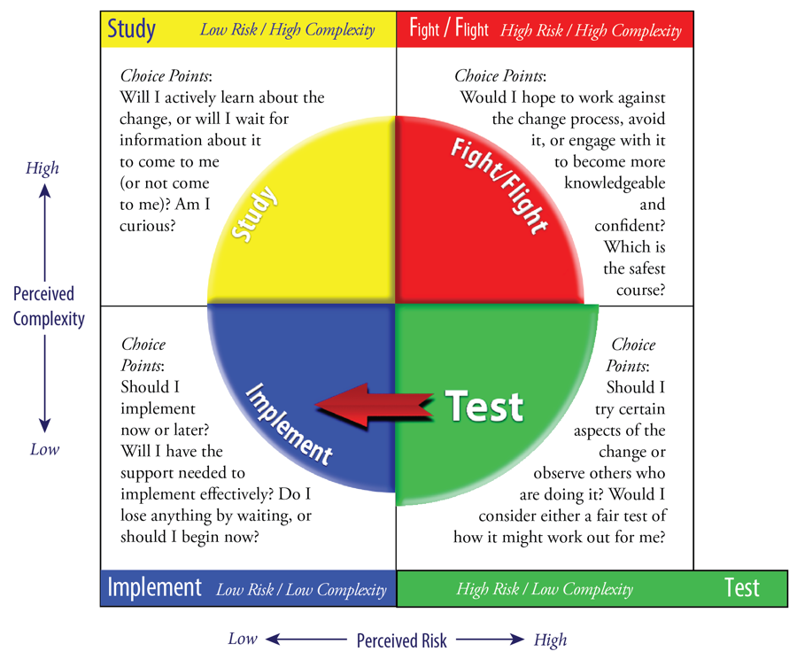

APPROPRIATE INTERVENTIONS
The following general intervention types are associated with specific reaction types:

- Fight/Flight
  - Reduce perceived complexity
    - Provide general training/education about underlying reasons for change, stages/steps of change, and actions to be taken by individuals in the “to-be” state.
  - Reduce perceived risk
    - Identify informal influencers
    - Identify informal influencer needs
    - Identify most practical/useful/applicable aspects of the change
    - Cross-matrix needs with useful aspects
    - Provide environment for interaction between informal influencers and useful aspects
    - Leverage perceived personal benefit via social networking tools
- Test
  - Reduce perceived risk
    - Identify informal influencers
    - Identify informal influencer needs
    - Identify most practical/useful/applicable aspects of the change
    - Cross-matrix needs with useful aspects
    - Provide environment for interaction between informal influencers and useful aspects
    - Leverage perceived personal benefit via social networking tools
  - Avoid complexity-reduction education/training
- Study
  - Reduce perceived complexity
    - Provide general training/education about underlying reasons for change, stages/steps of change, and actions to be taken by individuals in the “to-be” state.
  - Avoid risk-mitigation strategies and activities
- Implement
  - Assess implementation needs
  - Provide rapid implementation support
  - Avoid complexity-reduction and risk-mitigation strategies and activities

