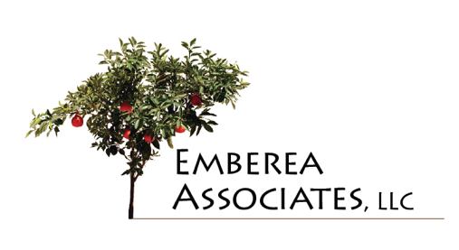
www.emberea.com

ACTION OVERVIEW:
Organization Development (OD) Tools

SUMMARY
All of our practitioners are expert in the understanding and use of a broad array of OD tools. Emberea Associates, LLC can be your full-service change and OD partner.

OD TOOLKIT
Some of the OD tools we use to help focus your change and performance efforts:

- Process Analysis
- Organizational Alignment and Design
- Collaborative Organizational Design
- Action Research
- Process Consultation
- Diversity and Inclusion
- Appreciative Inquiry
- Strategic Planning
- Future Search
- Performance Management
- Conflict Management
- Training and Development
- Training Trainers and Facilitators
- Coaching (Executive, Employee, Corrective)
- Team Formation, Dynamics, and Development
- Collaboration (In-person and Virtual)
- Agile Processes
- Team Process Consultation
- Leadership and Managerial Training and Development
- Interpersonal Skill Development

