Introduction to Dialectical Change Processes for Organizational Improvement (DCPOI™)
©Glenn P. Allen, Executive Partner, Emberea Associates

Typically, everyone in an organization can describe, even in the most general terms, what the organization does: “We educate.” “We build aircraft.” “We develop software solutions.” There is agreement. The further down one goes into an organization’s functions, however, the greater the differences become in terms of language, meaning, and mutual understanding. Organizational change slices through multiple levels of an organization simultaneously, with each sub-unit required to adapt its own unique functions and processes to whatever the new may be. As change wends its way through an organization, it is as if two new organizational units are formed: the “to be” unit and the “as is” unit. Each speaks its own language, holds its own basic assumptions, and defines truth and fact in its own particular way. The “to be” unit represents the change itself and deliberately holds it out as “this” change. The “as is” unit represents the current state and frequently sees change as “that” change.

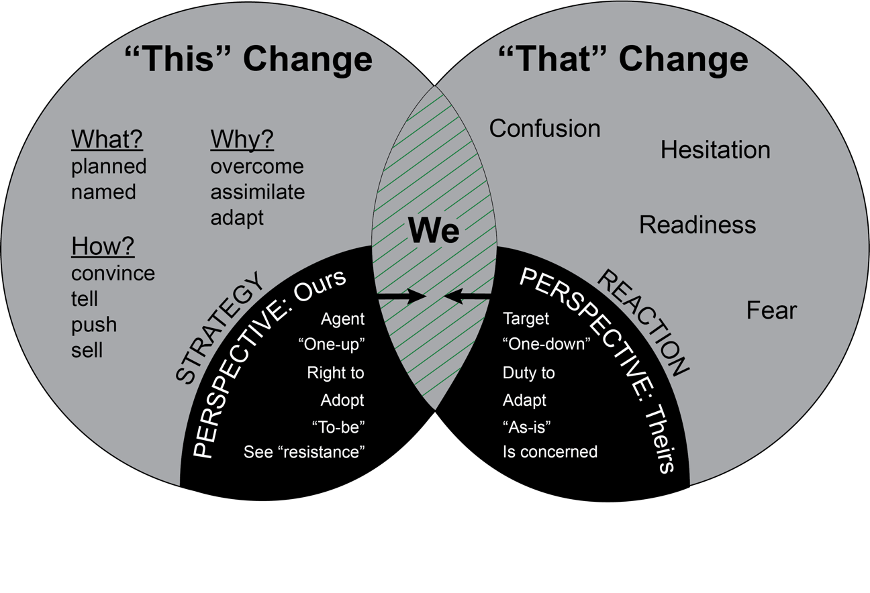

The unit that perceives the change as “ours” or “this” holds various perspectives about themselves and uses certain strategies to move change forward. The unit that perceives the change as “theirs” or “that” holds various perspectives about themselves and has certain reactions to change as change is moved forward toward them. The “We-zone” sits between these two metaphorical units and is the place where change can be seen to grow, expand, and make a tangible difference to the organization. Perspectives, strategies, reactions, and characteristics are described below.

Perspectives Inside Change: Ours
Agent. Those who represent the (“this”) change have the ability to do official things on behalf of the organization and its change. They are expected to implement. This agency is enshrined in the term generally applied to those who implement change—change agents.

One-up. When one perceives agency over another, can drive others toward goals they might not currently share, and have the sanctioned right to do so, we can say they are “one up” from those who do not hold such rights. To be one-up is to have greater access to power, authority, and resources than do those who are one-down. An interesting phenomenon in the context of change is that those who are one-up have the right to apply a name to a change effort whereas those who are one-down are expected to adopt both the name and the change represented by the given name.

Right to. The perspective of agency on behalf of the to-be state develops in one a sense of righteousness. By this we do not mean to imply zealousness. Rather, agency on behalf of the to-be state gives one the sense they have a right to engage in certain actions on behalf of the change. They are usually sponsored to do so by those with leadership authority.

Adopt. The goal of any change strategy is to drive toward adoption of the new. The perspective of change agents is that they have the right to (or the responsibility to) engage in actions that lead to adoption. There can sometimes be a large gap between the implementation and the adoption of change, however. Adoption puts into practice that which the change strategy implements.

To-be. The perspective of those empowered to act as agents of change is “to-be”. This perspective is forward-looking and goal-oriented. It considers “what is” to be a jumping off point for what is determined to be next.

Sees resistance. People with the one-up perspective tend to see the concerns and objections of those one-down as resistance whereas those who are one-down are just as likely to see the same as contributions to make things better for self and/or the organization.

Change Strategies
The above-mentioned perspectives inside the change process motivate the strategies typically chosen for the implementation of change.

What? Although change can happen incrementally and incidentally, most change efforts are formally planned. The “ours” perspective permits this. Even inclusive planning processes are sponsored, and sponsorship can be withdrawn. Change is most frequently named. Names serve as referents, making it possible to avoid referring to “this” change or “that” change. Names can be communicated easily, with meanings shared and implications understood. Names organize. They are at a higher level of logic than are the many and varied activities of which even a single change process is comprised.

How?
Even the most engaging of change methodologies are ultimately intended to convince others of the importance and value of adoption. This must be the case because organizational change strategies occur within the context of organizations, organizations where purpose must be served. A change with a “to-be” state that is counter to an organization’s current or future purpose would not be convincing. Hence, convincing is the purpose.

Some changes are implemented strictly by “telling” others what to do. Some organizations, whether by habit or design, hold telling as a basic assumption. Ample research suggests that such assumptions are least conducive to the success of a change and, ultimately, to an organization that operates on such assumptions and behaviors.

Many strategies exist for an organization to push change on those expected to adopt. An organization might offer training on the use of a new system and then simply “turn the key” on it. Another strategy is to use an organization’s reward structure to compel certain behaviors and deemphasize others.

One of the most common ways an organization can push a change on employees is to use the “What’s in it for me?” maxim. The intent is to help employees understand how a change can benefit them, personally. In this way, a change is “sold” for employee “buy in.”

Why?
Owners (agents) of change use the above-mentioned strategies to overcome objections to change processes and to assimilate as many targets of change as possible into the change. Those who will not willingly assimilate into the new way are expected to at least adapt to it. Change strategies are designed to overcome, assimilate, and bring about adoption.

The “We” zone from the perspective of “This” change
Change implementation strategies drive toward a place where as few people as possible see the change is “this” or “our” change. This is the goal of the strategies and the source of basic assumptions of the “Our” change perspectives. The We-zone represents the number of people who have at least adapted. The We-zone is a measure of the success of change strategies, strategies that may or may not result in resolution of the “theirs” “ours” dichotomy.

The perspectives of “That” change
When, as described above, one is part of the change implementation architecture, one tends to perceive the change as “this” change or refer to it as “ours”. Those not part of the implementation architecture—the targets of change—are just as likely to perceive the change as “that” change. It is not self. It is other. It is theirs, not ours. If the change is the thesis—the statement of what must be—then those who refer to “that” change have a perspective that is the antithesis. The “to be” is the thesis. The “as is” is the antithesis. This is the case because it is the change that is purposefully driven forward in an organization. It is the statement that is being made. It is the new reality that is being pushed. The “as is”—the antithesis—is the push back. The following perspectives are from this antithetical perspective:

Target. The perspective of a target is to be without agency. A change will be happening, liked or not, successful or not, and those so targeted must make the change. Even the most participatory methodologies are based on the fact that the organization needs targets of change to do something they might not want to do. Such methodologies have been proven to be persuasive and are, therefore, used ever-more frequently.

One-down. The lack of choice—or the granting of selected choice by those with authority and/or agency—creates the one-down perspective. One-down perspectives predominate where power, authority, and control come from outside oneself.

Duty to. Even when engaged in the most participatory manner, targets of change know it is their duty to align with the change in one way or another. Such alignment might take the form of adaptation to the change. It might also be complete adoption. Either way, accommodation or assimilation, targets know their duty. Their employment frequently rests upon it.

Adapt. At a minimum, targets of change hold the perspective that the change is something to which they must adapt. It is the target’s starting point of change, even when the change is to participate in the development of change. This is so because the target’s employment, or chance for advancement, frequently rests upon at least some form of adaptation.

As-is. Those with the perspective of “that” change first see the condition of “no change.” They come from the perspective of the as-is state. They know what is and they can’t yet know what will possibly be. At its core, the as-is perspective is the root of seeing “that” change instead of “this” change. It is central to the notion that ownership lies elsewhere.

Is concerned. In a Democratic system, there is no true “Resistance” because those with concerns can always amass political support to turn agents into targets. Organizations, however, are not democracies and those with concerns about change are often seen as resisting change. A great many organizational change strategies exist for the purpose of “overcoming resistance”. The perspective of those who see “that” change (who see the change as “other” or “theirs”) is generally not “I am resisting this change.” They know that pure resistance will never fully succeed. People with the “their” perspective about “that” change tend to have, instead, concerns about change. Even when voiced as objections, such objections, when listened to, usually emerge as concerns that can be addressed or negotiated.

Reactions to “that” change
Our research shows four generalized and clear reactions to change: confusion, fear, hesitation, and readiness.

Confusion is characterized by a lack of understanding about the content or application of change. It is also characterized by a low sense of personal risk. When confusion predominates, one might say “I don’t understand this, but I don’t feel at risk.” Fear is a reaction that occurs when there is a high degree of confusion and a high degree of perceived risk. Hesitation is a reaction to a large amount of perceived risk but a low degree of confusion. Readiness is a reaction to low perceived risk and a low degree of confusion, particularly when personal benefit is perceived.

The “We” zone from the perspective of “That” change
Perspectives and reactions of those who see change as “theirs” or see the change as “that” change tend to push back against momentum of “this” change. This limits engagement. The We-zone will not grow. The goal of change implementation strategies is to convert the perspective of targets in the following way:

- One-down > Part-of
- As-is > To-be (or new “is”)
- Done to > Part of
- Resistance > Alignment
- Duty to > Willingness to

Perspectives of “this” change and “that” change tend to push against one another, limiting the size and expansion of the “we” zone. In many organizational change processes, equilibrium is maintained at a point where a change is neither all “this” nor all “that”. The from>to formula is incomplete, the growth of the We-zone stalls, and change is sub-optimized.

Expansion of the “We” zone
We can say that the “We” zone expands as an ever-greater number of people adopt a change. When people see “this” change and “that” change (ours/theirs), forces press against one another and the “We” zone cannot expand. Resolution of the this/that ours/theirs dichotomy expands the We zone.

As mentioned above, we can think of change as a proposition or a thesis. In the context of change, and from the perspectives of those engaged in it, we can see how this change thesis is perceived in at least two different ways: “this” change and “that” change; “our” change or “their” change. Each change perspective is paired with what appears to be its opposite or its anti-thesis. This thesis-antithesis dichotomy is what is known as the dialectic. If, during change, the dialectic is unaddressed, the We-zone is small and expansion is limited—people perceive the change as either ours or theirs. Were we to ask change agents and change targets (those who remain outside of the We-zone) to describe the other, they would likely display what they consider to be firm facts about these others. They would report knowing or understanding who the other are, what perspectives they hold, and how and why they behave as they do. They would hold this knowledge as Truth. In this way, they objectify the other and the We-zone cannot grow. Dialectical methods presume that such objectification can not describe “Truth”. Dialectical methods provide ground for:

- Learning about mutual needs and wants
- Measuring reactions and understanding them to be temporary, not permanent, states
- Moving from reactions to productive responses
- Evaluating progress toward We-zone expansion

Our dialectical methods presuppose that openness is far more productive than is the objectification of the other.

Dialectical Change Processes for Organizational Improvement (DCPOI)™
Our dialectical change processes lead to organizational improvement by bridging the gap between those who see an organization’s change as “ours” and those who see it as “theirs”. Our work expands the We-zone—that space where unanticipated improvements happen. With DCPOI™ tools, as the change strategy, the following responses to change help expand the We-zone:

- Listening
- Implementing
- Studying
- Testing

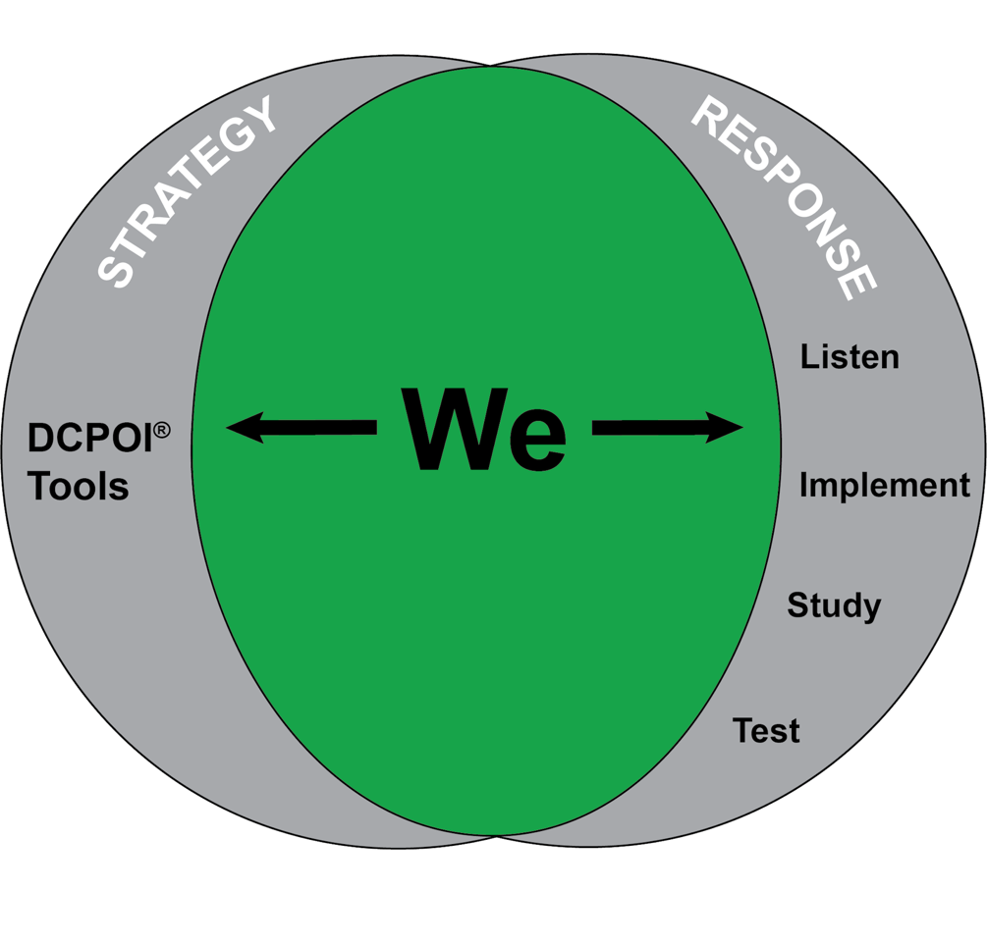

The DCPOI™ toolkit
We use the following tools the bridge the dialectic and increase the size of the We-zone:
- 8-Step Nameless Change Process
- The Reaction Reflector
- Reaction-focused interventions
- OD-based practices

The Nameless Organizational Change process is detailed in the book Nameless Organizational Change (2000). The process wins over the hearts and minds of people at work by helping them experience personal benefit in what the change has to offer. Where “What’s in it for me?” tends to tell people what they should get out of the change, the Nameless Change process helps people actually experience personal benefit. The process also helps change disseminate across an organization via the principles of social network theory.

The Reaction Reflector© is a tool accessible through Emberea Associates (www.emberea.com). This evidence-based tool provides a detailed snapshot of reaction to change at any given time in any part of an organization or across the organization-as-a-whole. It also gives each person who takes it an analysis of the sources of their reaction and unique-to-them tools they can use to potentially perceive personal benefit in a change and to move from automatic reaction to productive change response.

Reaction-focused interventions include large-scale actions taken to address the sources of specific reaction types and individual actions that help coach people toward productive response.

We use master-level OD (organization development) tools to help with local and global issues in your organization during change. OD tools help bridge the dialectical divide and expand the We-zone.

